***Curriculum Vitae***

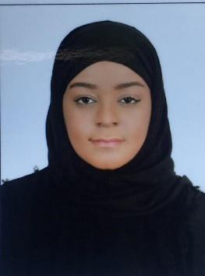***To,***

***Human Recourses Manager,***

***Human Recourses Department,***

***Kingdom of Bahrain***

***Dear Sir***

***Sub: Suitable Position***

***Kindly allow me to list down and brief you of my background history and experience I have gone through for you to consider my application for any vacancies with your esteemed organization.***

***I am taking this opportunity to thank you for the kind and valuable time you are sparing to go through my attached CV.***

***My background includes working as Shop Manager. Operator, Cashier. I believe I can make a positive contribution to your organization and look forward to discussing my capabilities in more detail, in your organization in an interview arranged at your convenient time.***

***I look forward a favorable reply from you.***

***Yours faithfully***

***Hanan Humood Nasser alfeel***

***Hanan Humood Nasser alfeel***

***Building- 332 Road-411 blk- 1004 Al Jasra***

***Mobile: 36200807***

***Email: hananalfeel@Hotmail.com***

***PERSONAL DETAILS***

***Nationality* *:* *Bahraini***

***Date of Birth* *:* *12th August 1987***

***C.P.R No.* *:* *870818066***

***Marital Status* *:* *Single***

***CAREER OBJECTIVES***

***Motivated by self-interest & a career-improvement nature.***

***I have an excellent communication skill with an efficient teamwork spirit.***

***Wide variety of skills & an experienced in Office work. I am hard working and adaptable individual, with good experience of maintaining good sales skills and call center experience. I enjoy both varying alone or within a team, and I am keen no use my own initiatives. I am patient and flexible, stay calm in difficult situation.***

***I am officially applying for a job opportunity in your company. I believe I can achieve a better carrier in a well establish organization such as your Company. I am very self-motivated and responsible person with a high ability to learn and improve.***

***WORK EXPERIENCE***

***Pathway Express parcel Services***

***Operator & Call Center***

***11th of November 2017***

***1st of July 2019***

***Training courses***

1. ***Yes I Can***

***2. Responsible Business***

***3. English ILIS***

***LANGUAGE KNOWN***

1. ***Arabic***
2. ***English***